User manual for REACH Admin

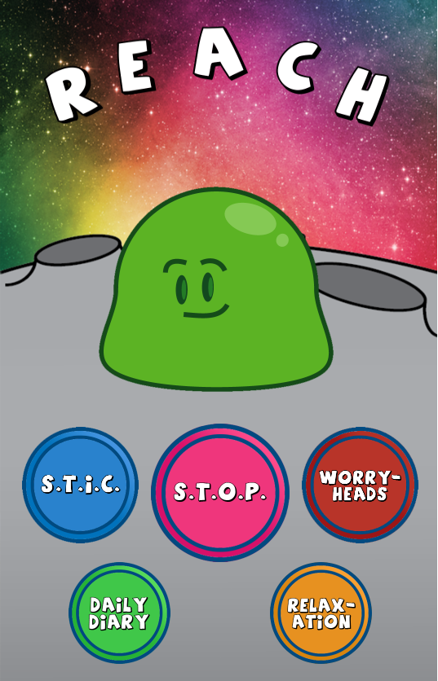

Table of Contents:

1. ADMIN SETTINGS
2. ADMIN SETTINGS

Tap the main screen starting from top left corner, top right corner, bottom right corner and then finally bottom left corner in quick succession.

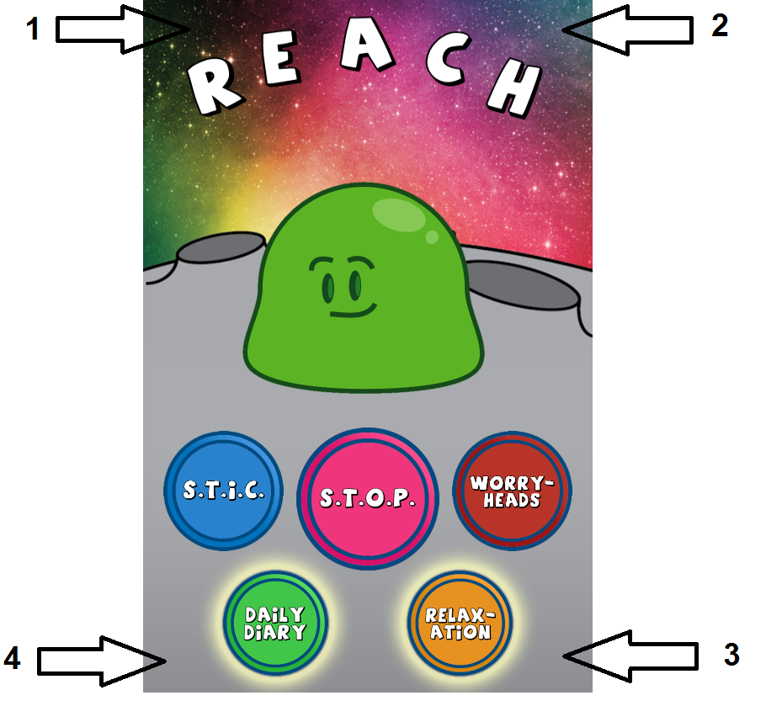

Type in the admin pin to go in the admin preferences.

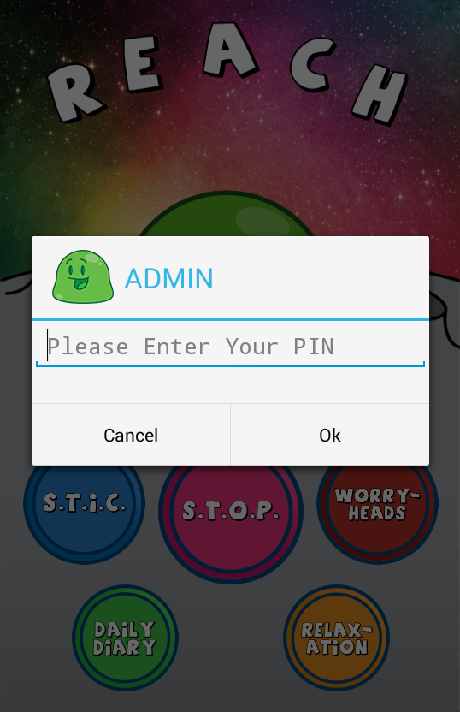

This is the list of options available for Admin.

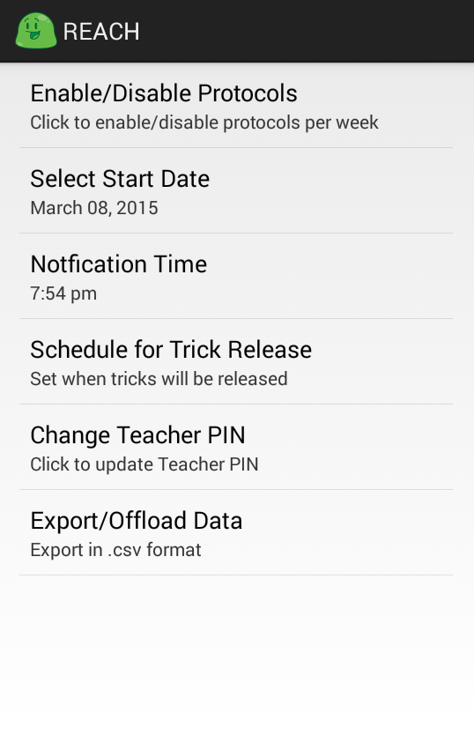

Tap the option of your choice to change a particular setting.

Select the start date of the protocol, notification time and BLOB trick release days of the week.

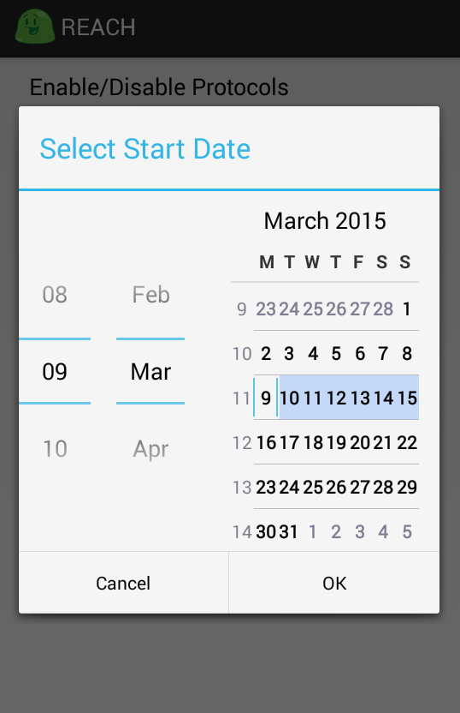

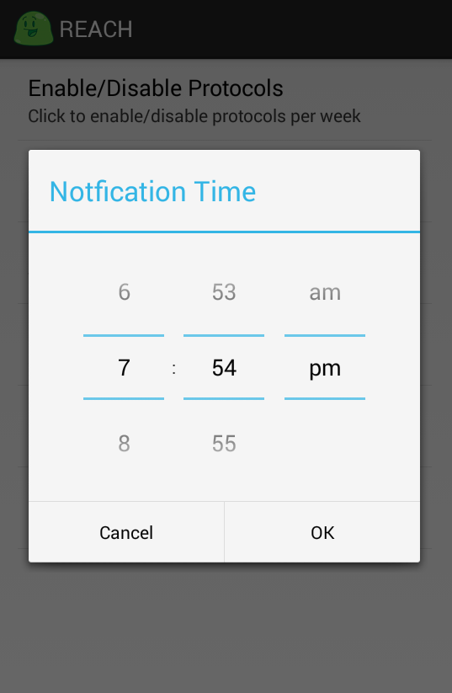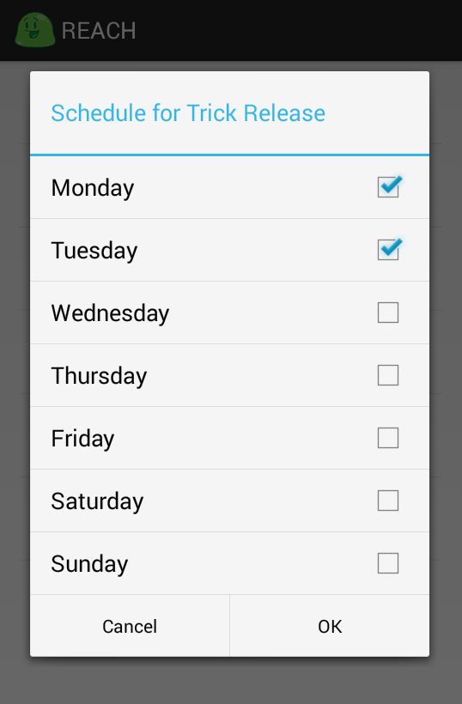

Change the protocol settings for a particular week.

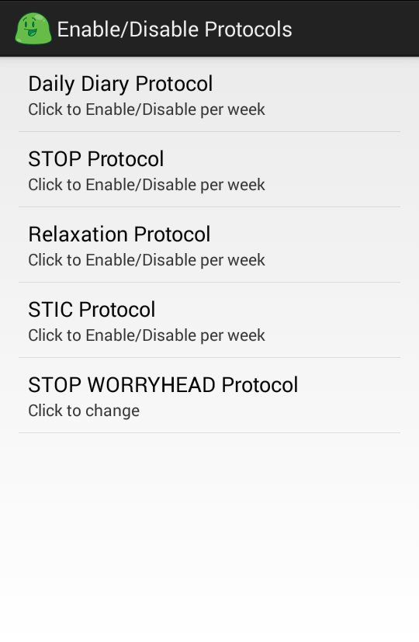

Select the week you want a particular protocol to take place.

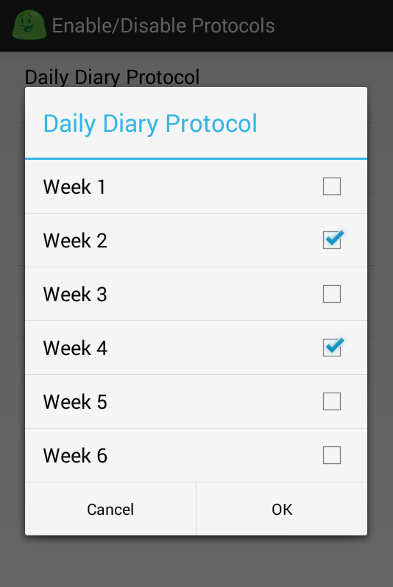

Export the logged data using a Share intent. GMAIL is already configured to send an email to [Heal@asu.edu](mailto:Heal@asu.edu) with a CSV file showing logged data of the activities.

